System Context Brief
  - IIIT Hyderabad Breakfast Mess System
Table of Contents

System Boundary and Context

System Boundary
The system under study is the breakfast meal registration, billing, and service process operated across the four residential dining messes at IIIT Hyderabad — Kadamba, Palash, Bakul, and Yuktāhār — together with the digital registration and billing platform (dining.iiit.ac.in) that governs access to all four. The boundary includes the interface between this system and the academic class schedule, since the two operate on overlapping but independently controlled timings.
On-campus alternatives that compete for the same demand — Vindhya Canteen, the juice canteens, and third-party food delivery services — sit at the edge of this boundary. They are not part of the mess system’s own operation, but they materially affect it: a student who does not eat at a mess draws instead on one of these.
Lunch and dinner registration at the same four messes fall outside this boundary. The system described here is scoped to the breakfast meal, though it runs on the same underlying platform and the same rules as the other two meals.
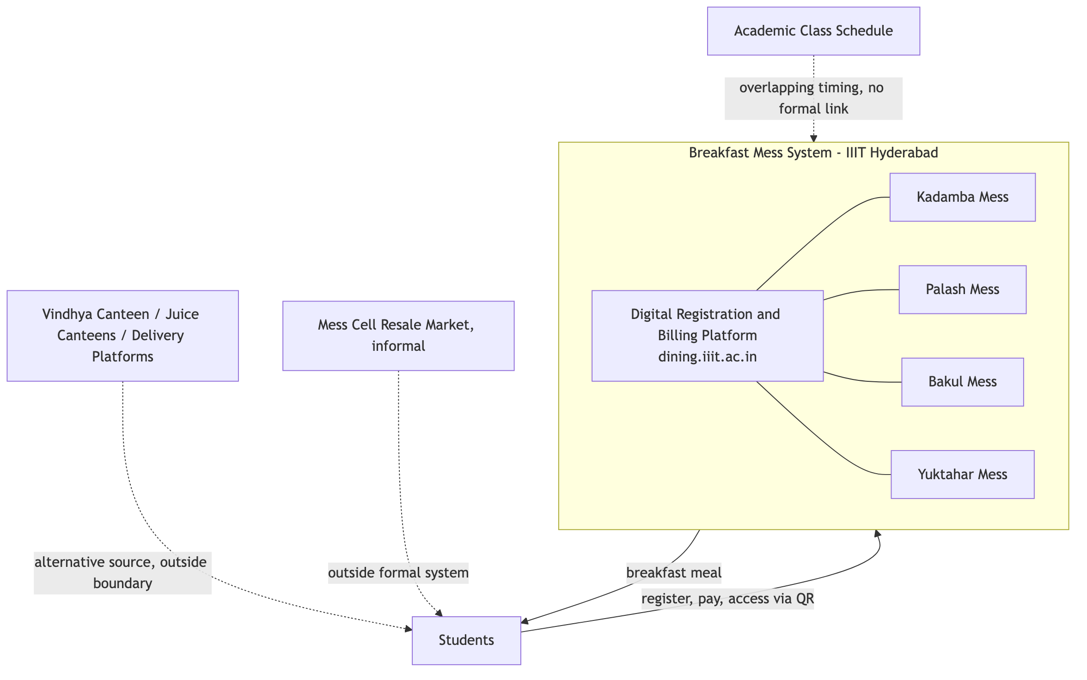
System Boundary

Context
The breakfast system serves the entire resident student population of the institute across four messes, operating daily from 7:30 AM to 9:30 AM. Total confirmed breakfast capacity across the four messes is approximately 2,755 registrations per day: Kadamba (700 vegetarian, 600 non-vegetarian), Bakul (350 vegetarian, 350 non-vegetarian), Palāsh (400), and Yuktāhār (340 regular, 15 Jain).
Structurally, the system combines centralized demand management with decentralized supply. A single digital platform governs registration, billing, and access across all four messes, while food production itself is distributed and non-uniform. Kadamba operates its own kitchen and vendor. Palash and Bakul share a vendor: food is cooked centrally at Palash and physically transported to Bakul, which additionally prepares non-vegetarian food on-site, since Palash’s kitchen cannot produce non-vegetarian food at all. Yuktāhār operates independently and is the only mess offering a Jain food registration option. Four different production arrangements are unified only at the registration, billing, and access layer — the mess system is not one kitchen serving one population through one process, but a coordinated platform sitting over four structurally different operations.
The system operates inside, and is shaped by, several adjacent systems it does not control:
- Academic administration and class schedule. Classes begin at 8:30 AM and run until 6:40 PM, with a class lunch break from 1:00 PM to 2:00 PM. Class scheduling is not continuous — most students have a limited number of classes on a given day — and there is no formal channel of coordination between the mess system and the academic calendar; the two schedules are set independently of one another by separate authorities.
- Warden and Mess Committee governance. Vendor management and any operational change to the mess sit with the Warden. Mess-specific decisions, including the menu, sit with the Mess Committee, which incorporates student input on menu content approximately one month ahead of service.
- An informal peer-to-peer resale market (“Mess Cell”). A WhatsApp group has formed in which students who hold a breakfast registration they will not use offer it for resale to other students at a negotiated price below the registered rate. This market operates entirely outside the mess system’s own registration and billing infrastructure, transacted through the same personal QR-based access credential the formal system issues.
- The wider campus food ecosystem. Vindhya Canteen (open Monday to Saturday, from 10:00 AM), the juice canteens (open mornings), and delivery platforms (accepting orders until 11:00 PM, with delivery personnel required to remain outside the campus gate) all draw on the same student population and stand as alternatives to mess breakfast.
Billing operates on a monthly cycle tied to registration, not attendance: a student is charged for every meal they are registered for, regardless of whether they eat it, and may cancel a registration in advance, subject to a limit of five cancellations per meal type per month. Unregistered (“walk-in”) access to a meal is priced materially higher than registered access to the same meal.
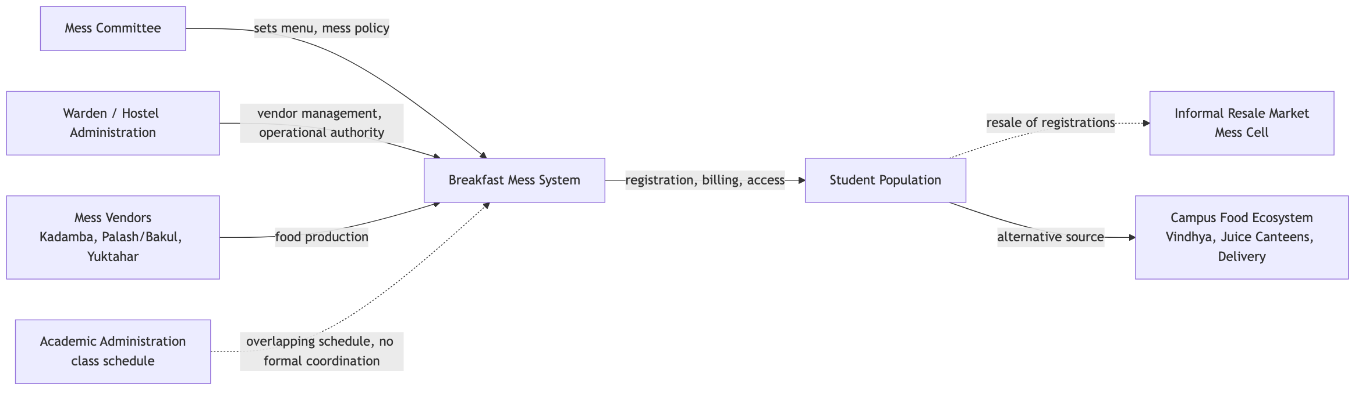
Context Map

Purpose and Intended Outcomes

Purpose
The breakfast mess system exists to provide the resident student population with reliable, adequate, good-quality food each morning, at a predictable and affordable cost, accommodating dietary requirements — vegetarian, non-vegetarian, and Jain — in a manner that supports student health, energy, and academic performance.

Intended Outcomes
- Every registered student obtains a breakfast meal matching their dietary requirement within the operating window.
- Food quality and preparation quantity remain consistent with actual demand, minimizing both shortage and waste.
- The cost structure remains affordable and predictable for students across a full semester.
- Access to breakfast does not depend on a student’s ability to navigate informal workarounds; the formal system functions as the primary and sufficient channel on its own.
- The system remains responsive to changes in student needs and circumstances — schedule conflicts, dietary changes, feedback — through its own governance structure.

Visible Symptoms and Underlying Issues
Visible Symptom | Underlying Issue
A student registers for breakfast, does not attend, and is still charged the full registered price. | Billing is tied to registration, not attendance. The cost is incurred at the point of registering, independent of whether the meal is ultimately consumed.
The registration platform imposes a cap of five cancellations per meal type per month. | Uncancelled, unattended registrations occur often enough, across the student population, that an explicit limit was necessary to manage them — the cap is itself evidence of the scale of the pattern it constrains.
A “Skip Meal” function lets a student notify the kitchen in advance that they will not attend, but this does not reduce or refund the charge. | The mechanism built for anticipated non-attendance addresses only the kitchen’s production planning, not the student’s cost. It returns zero value to the student for the same situation a cancellation — capped at five per month — would address instead.
An unofficial, student-run resale market (“Mess Cell”) has formed, where students sell registrations they will not use to other students at a negotiated price. | Reselling a registration returns partial or full value to the student, while using Skip Meal returns none. For a student who knows in advance they will not attend, resale is a materially better option than the system’s own built-in mechanism for the same situation — the formal tool is outcompeted by an informal one because it was designed to reduce kitchen waste, not to return value to the student.
Registered-but-unclaimed meals persist despite both a cancellation option and a resale market being available. | Cancellation and resale both require advance knowledge that the student will not attend. Non-attendance decided at the last minute — oversleeping, running out of time, a change of plans — has no mechanism available to it at all; this is the specific category of registration that converts into prepared, uneaten food with no value returned to anyone.
Walk-in (unregistered) access to a meal costs substantially more than the same meal accessed through a prior registration. | The pricing structure creates a standing incentive to register in advance even when attendance is uncertain, since deciding same-day costs more. Registration counts are inflated by this incentive independent of a student’s actual intention to attend.
Bakul’s registered attendance is consistently lower, relative to its own capacity, than Kadamba’s. | Bakul is a more recently established mess, physically situated in a converted warehouse rather than a purpose-built dining hall, created specifically to add non-vegetarian capacity once Kadamba’s own capacity was reached; part of its food supply is transported from Palash rather than produced on-site. Kadamba is the original and most established mess.
Neither students nor mess-side staff describe a visible channel through which mess feedback leads to a change in policy, hours, or operations. | The Mess Committee’s stated process for student input applies to the menu specifically; no equivalent process exists for structural matters such as operating hours or the billing model. This absence is also why the overlap between breakfast hours and the academic schedule has never been formally raised — there is no established path for a cross-authority issue to be escalated by either side.
Breakfast hours (7:30–9:30 AM) overlap with the start of the academic day (8:30 AM), while the two schedules are set by entirely separate authorities. | The Warden and Mess Committee control mess operations; the academic administration controls class scheduling; neither has authority over the other’s schedule, and no coordination mechanism links the two. A timing conflict between them can persist indefinitely without either side being positioned to resolve it unilaterally.
The registration platform includes a random-allocation mechanism, evidenced by a settings option to notify a student when they have been randomly allocated a meal. | Some registrations are generated by the system itself rather than by active student choice. Recorded registration counts do not uniformly represent expressed intent to attend.
A portion of students report skipping breakfast for reasons unrelated to the mess system’s own operation — personal dietary practice, sleep schedule, and established habit. | Breakfast non-attendance is not driven by a single cause. It includes a population of students whose non-attendance would persist regardless of any change to mess hours, pricing, or process, because the driving factor is a personal routine formed independently of the mess system.
Students report that companionship affects whether they attend breakfast — attendance is more likely when a roommate or friend is also going. | Breakfast attendance, for at least part of the student population, is a socially coordinated decision rather than a purely individual one; a student’s own registration does not reliably predict their attendance independent of who else is going that morning.

Key Actors, Institutions, Processes, Resources and Constraints

Actors
- Students — the registrants and consumers of the meal; attendance and dietary preference vary across the population.
- Mess Committee — sets the menu and mess-specific policy, incorporating student input approximately one month in advance.
- Warden — holds authority over vendor management and any operational change to the mess.
- Per-mess vendors — Kadamba’s vendor; the shared Palash/Bakul vendor; Yuktāhār’s vendor.
- Mess serving and cleaning staff — also consume mess food after student service hours conclude.
- Academic administration — sets the class schedule; holds no authority over mess operations.
- Students participating in the Mess Cell resale market — an unofficial secondary role occupied by a subset of registered students.
- Guests — parents, visiting relatives, and non-student campus affiliates who pay the vendor directly for access.

Institutions
- The Mess Committee and the Office of the Warden, jointly holding mess governance.
- The academic administration/timetable authority, operating independently with no formal link to mess governance.
- The four mess vendors, operating as independent entities under one shared registration platform.

Processes
- Registration — a student selects a mess and meal date through the digital platform in advance of service.
- Billing — charges are applied monthly, calculated from registration count, independent of attendance.
- Cancellation — a registered meal may be cancelled in advance, up to five times per meal type per month, removing the associated charge.
- Skip Meal — a registered student may flag in advance that they will not attend; this notifies the kitchen for production planning but does not affect billing.
- Access — a student presents a personal QR code at the mess counter to receive a plate matching their registered dietary category. The code can be reset at any time, and mess staff can reassign it on the spot if a student eats at a different mess than the one registered.
- Walk-in access — a student without a registration may pay the vendor directly at a higher rate, subject to a separate, smaller capacity allocation.
- Resale — outside the formal platform, a registered student may transfer their registration to another student through the Mess Cell WhatsApp group, in exchange for a negotiated payment.
- Menu setting — the Mess Committee finalizes the menu approximately one month ahead of service, incorporating student input.

Resources
- The digital registration and billing platform (dining.iiit.ac.in).
- Four physical mess facilities of differing capacity and origin — Kadamba (purpose-built, largest capacity), Bakul (a converted warehouse), and Palash and Yuktāhār as separate facilities.
- Per-mess food production capacity, distributed unevenly — Kadamba and Yuktāhār produce on-site; Bakul’s vegetarian supply is transported from Palash while its non-vegetarian food is prepared on-site.
- The personal QR access credential issued to each student.

Constraints
- Billing is registration-based, not attendance-based, and cancellations are capped at five per meal type per month.
- Walk-in pricing is set materially higher than registered pricing.
- Vegetarian and non-vegetarian food is segregated by registration type at the point of service.
- Palash’s kitchen cannot produce non-vegetarian food — a fixed physical limitation, not a policy choice.
- Mess operating hours and the academic class schedule are set independently by separate authorities, with no formal coordination mechanism between them.
- Governance authority over mess operations rests with the Mess Committee and the Warden; the academic administration has no formal role in mess-related decisions.

Initial Problem Framing
Students register for breakfast at a materially higher rate than they attend, converting a portion of registered demand into food that is prepared and paid for but not consumed. The system’s own mechanisms for anticipated non-attendance — cancellation and Skip Meal — return no value to the student in the case of Skip Meal, and require advance knowledge in both cases; an informal resale market has emerged to fill this gap for planned non-attendance, while unplanned non-attendance remains entirely unaddressed.
Separately, and not fully overlapping with this pattern, a subset of students do not attend breakfast for reasons independent of the mess system itself — personal dietary practice, sleep schedule, and established habit.
The central question this raises is whether the registration-and-billing structure itself is producing or reinforcing non-attendance — by rewarding advance commitment without rewarding actual attendance or providing flexibility — or whether it is a neutral backdrop to a pattern driven primarily by factors outside the system’s control, and to what extent the overlap between breakfast hours and the start of the academic day is a contributing factor as opposed to one visible symptom among several independent ones.

